Eclipse-Force.com IDE Installation

Steps to configure Force.com IDE:

- Download and install the latest version of the Java JDK(Version 1.8) from the link below and set path.
http://www.oracle.com/technetwork/java/javase/downloads/index.html

- Download and install the Eclipse IDE for Java EE Developers from the following link.
http://www.eclipse.org/downloads/packages/release/Kepler/SR2

- Install the Force.com IDE by following the steps below.
    - Launch Eclipse and click Help > Install New Software....
    - Click Add....
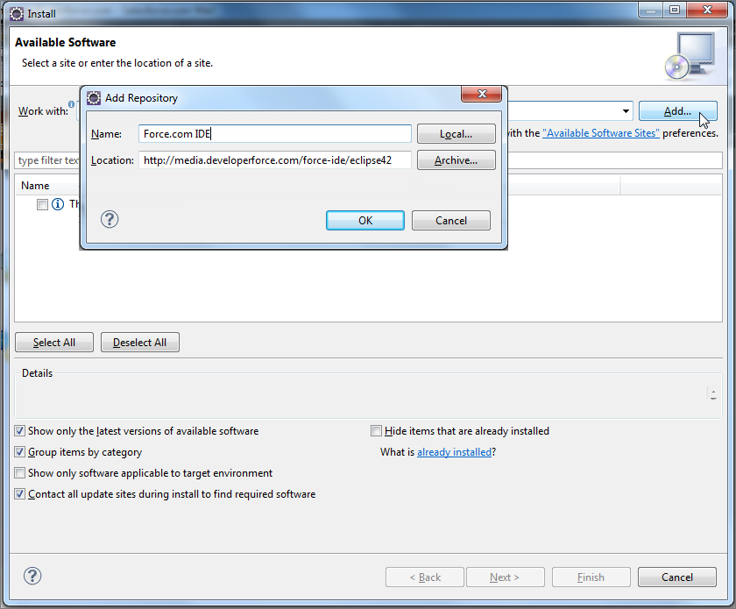
    - In the Add Repository dialog, set the Name to "Force.com IDE" and the Location to https://developer.salesforce.com/media/force-ide/eclipse45. For Spring ’16 (Force.com IDE v36.0) and earlier Force.com IDE versions, use http://media.developerforce.com/force-ide/eclipse42.
    - Click OK.
    - If you want to install an older version of the plug-in (for example, if you do not have Java 8), be sure to clear the option "Show only the latest versions of available software."
    - Eclipse downloads the list of available plug-ins and displays them in the Available Software dialog.
    - Check the box next to the Force.com IDE plug-in and click Next.
    - In the Install Details dialog, click Next.
    - In the Review Licenses dialog, accept the terms and click Finish.
    - Eclipse downloads and installs the Force.com IDE and any required dependencies. When installation is complete, you will be prompted to restart. Click Yes.
    - When Eclipse restarts, select Window > Open Perspective > Other, select Force.com and click OK

- Configuring proxy setting in eclipse.
    - In Eclipse IDE, select Window –> Preferences.

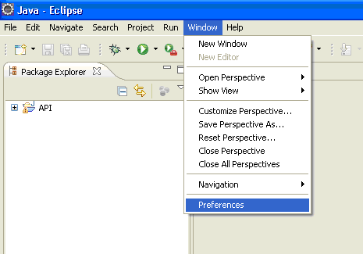

    - Preferences box prompt out, choose General → Network Connections.
    - Select Manual from Action Provider drop down list.
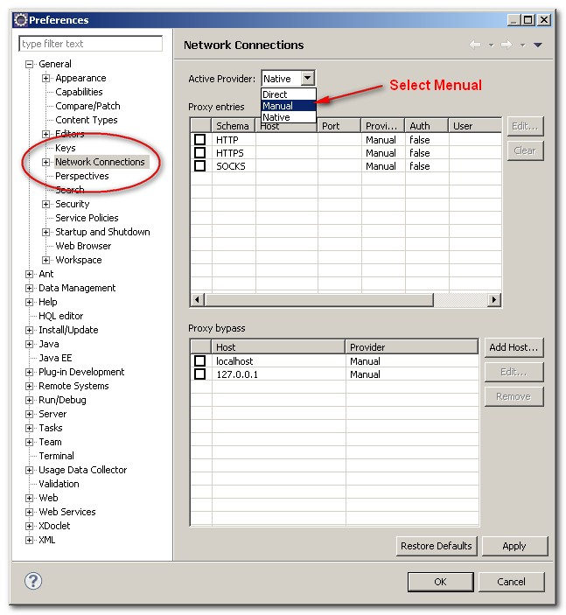

    - Select HTTP in the List and click Edit button.
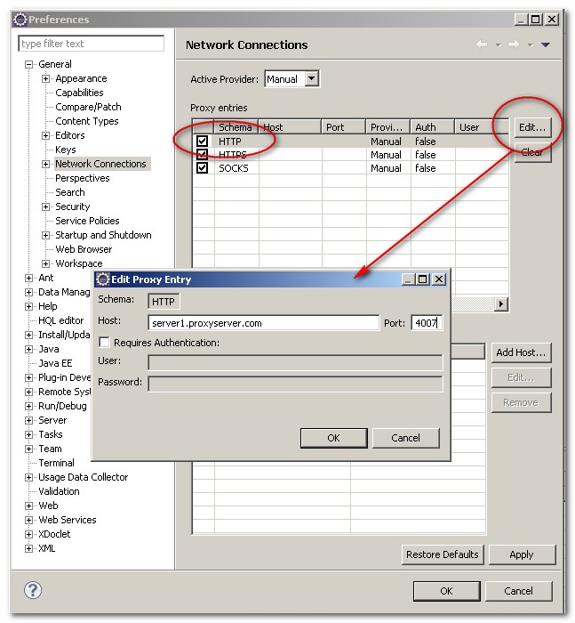

    - Enter Host as Webproxy.int.westgroup.com and port as 80.
    - Follow steps 4 and 5 to change proxy for HTTPS and SOCKS(same host and port).
    - Click Ok.

5. Increasing the eclipse heap size for handling large org data.
        - Open the eclipse folder.
        - Open the eclipse.ini file in notepad or notepad++.
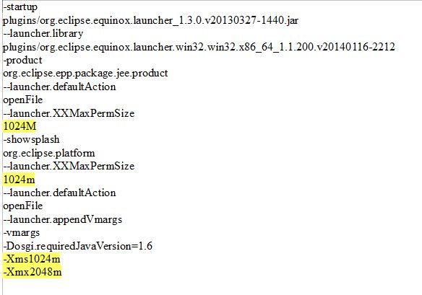
        - Edit the highlighted lines to match the text above.
        - Restart Eclipse.

6.Creating Force.com project
- In Eclipse IDE ,Select File→New→Force.Com Project.
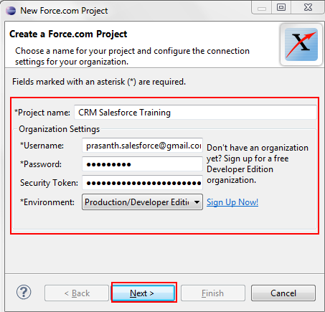

      - Enter any name for Project name of your choice.
      - Enter Username and password of your org.
      - Select appropriate Environment.
      - Enter security token if available.

Eclipse grows slower with use. The temporary files need periodic housekeeping and also the memory setting needs to be correctly done to improve performance. The following Eclipse plugin help to improve the performance of Eclipse and is recommended to be installed:

http://zeroturnaround.com/free/optimizer-for-eclipse/?utm_source=rebellabs

Read more about this tool at https://zeroturnaround.com/rebellabs/eclipse-having-a-slow-day-speed-it-up-in-a-few-clicks/

